Project Title: Secure Encrypted File Transfer & Storage System
Name: S. Krishna Kumar
Platform / Context: Cybersecurity / Secure Communication & Data Protection (Kali Linux)

1. INTRODUCTION
In modern networked environments, secure data transmission and storage are critical due to the increasing number of cyber threats such as eavesdropping, data tampering, and unauthorized access. Transferring files over insecure channels can lead to data leakage, manipulation, or interception by attackers.
This project implements a Secure Encrypted File Transfer and Storage System that ensures confidentiality, integrity, and secure communication between a client and a server. The system uses AES-256 encryption, HMAC integrity checks, and TLS (SSL) secure channels to protect files during transmission and while stored on the server.
The project is designed for educational purposes and demonstrates real-world secure file handling techniques used in cybersecurity and secure system design.

2. OBJECTIVES OF THE PROJECT
The main objectives of this project are:
• To implement secure file upload between client and server
• To ensure confidentiality using AES-256 encryption
• To ensure data integrity using HMAC-SHA256
• To protect communication against Man-in-the-Middle (MITM) attacks using TLS
• To store files securely in encrypted form on the server
• To handle binary files such as images, documents, and archives
• To gain hands-on experience with secure network programming

3. SCOPE OF THE PROJECT
Included:
• Secure TLS-based client-server communication
• Encrypted file upload
• Chunked transfer for large files
• HMAC-based integrity verification
• Encrypted storage on server disk
• Support for all file types (text, images, binaries)
• Local testing environment (authorized use)
Not Included:
• File exploitation or malware delivery
• Brute-force or password attacks
• Unauthorized network access
• Cloud-based storage
• Resume upload/download (future enhancement)

4. TOOLS & TECHNOLOGIES USED
Tool / Technology | Purpose
Kali Linux | Cybersecurity testing platform
Python 3 | Programming language
OpenSSL | SSL/TLS certificate generation
PyCryptodome | AES encryption & HMAC
SSL Module (Python) | Secure TLS communication
Socket Programming | Client-server communication
GitHub | Version control & project hosting

5. SYSTEM REQUIREMENTS
Hardware Requirements:
• Minimum 4 GB RAM
• 20 GB free disk space
• x86_64 architecture
Software Requirements:
• Kali Linux
• Python 3.x
• OpenSSL
• PyCryptodome library
• Internet connection (for GitHub)

6. METHODOLOGY
The secure file transfer system follows the steps below:
1. Secure Channel Establishment
The client connects to the server using TLS with a self-signed SSL certificate to establish an encrypted channel.
2. Key Generation
The client generates a random AES-256 key and initialization vector (IV) for encryption.
3. File Encryption
The file is read in binary mode, divided into chunks, and encrypted using AES-256-CBC.
4. Integrity Protection
Each encrypted chunk is authenticated using HMAC-SHA256 to detect tampering.
5. Secure Transmission
Encrypted chunks and HMAC values are transmitted over the TLS channel.
6. Secure Storage
The server verifies integrity and stores the encrypted file on disk without decryption.

7. ARCHITECTURE DIAGRAM
Client Server
------ ------
Select File ─────────────▶ TLS Connection
AES Encrypt ─────────────▶ Receive Encrypted Data
HMAC Add ─────────────▶ Verify HMAC
Chunk Send ─────────────▶ Store Encrypted File

8. IMPLEMENTATION DETAILS
Encryption
• AES-256-CBC mode is used for strong encryption
• Random keys are generated per session
Integrity Verification
• HMAC-SHA256 ensures that files are not modified in transit
Secure Channel
• TLS protects against sniffing and MITM attacks
File Handling
• Files are processed in binary mode
• Supports large files using chunked transfer

9. TESTING & RESULTS
Test Environment:
• Kali Linux (local machine)
• Client and server running on localhost

Test Cases:
File Type | Result
Text File (.txt) | Successfully encrypted and stored
Image (.png) | Successfully encrypted and stored
Binary File (.zip) | Successfully encrypted and stored
Observed Output (Server):
[+] Secure server listening on port 4443
[+] Client connected
[+] File stored securely

10. THREAT MODEL & SECURITY MITIGATION
Threat | Mitigation
Man-in-the-Middle | TLS encrypted channel
Data tampering | HMAC-SHA256
Data leakage | AES-256 encryption
Server compromise | Encrypted storage
Network sniffing | SSL/TLS

11. RESPONSIBLE USE & ETHICS
This project follows ethical cybersecurity practices:
• Used only in authorized environments
• No exploitation or malicious intent
• No interception of third-party data
• Intended strictly for educational and learning purposes

12. LIMITATIONS OF THE PROJECT
• Self-signed certificates are used
• No user authentication implemented
• Resume upload not supported
• No secure download feature (future scope)

13. SCREENSHOTS
• Server running
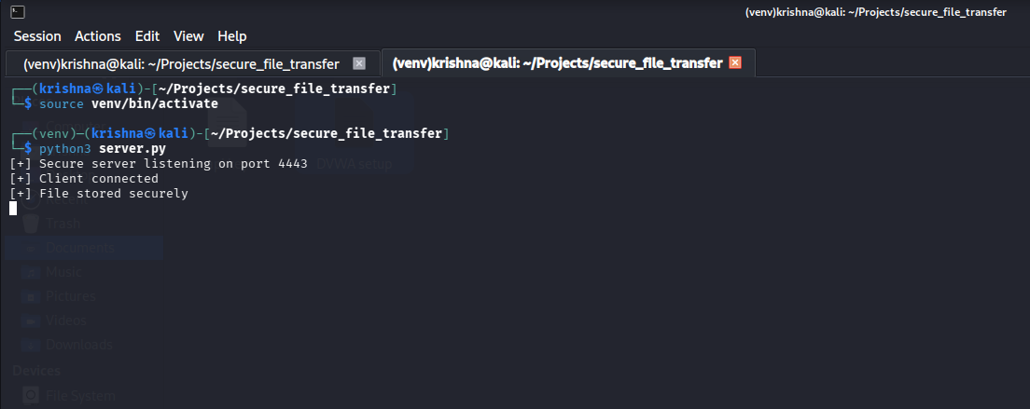
• Client uploading file
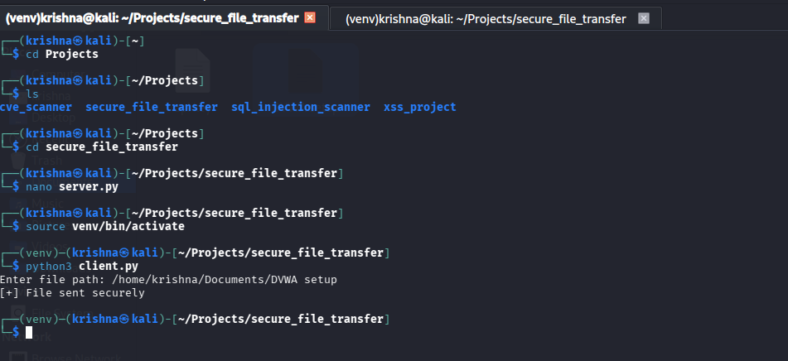
• Encrypted file in storage directory
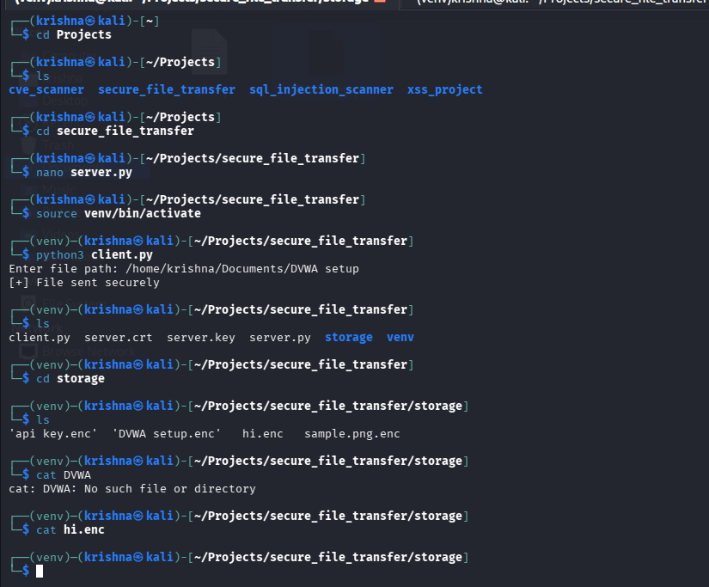

14. CONCLUSION
The Secure Encrypted File Transfer & Storage System successfully demonstrates secure communication principles using modern cryptography techniques. By combining TLS, AES encryption, and HMAC integrity verification, the project ensures confidentiality, integrity, and secure storage of files.
This project provides a strong foundation for understanding secure systems and can be extended further with authentication, download functionality, and resume support.

15. REFERENCES
• https://www.kali.org
• https://pycryptodome.readthedocs.io
• https://www.openssl.org
• https://owasp.org
• https://nvlpubs.nist.gov

